8. K-MEANS CLUSTERING BY WEKA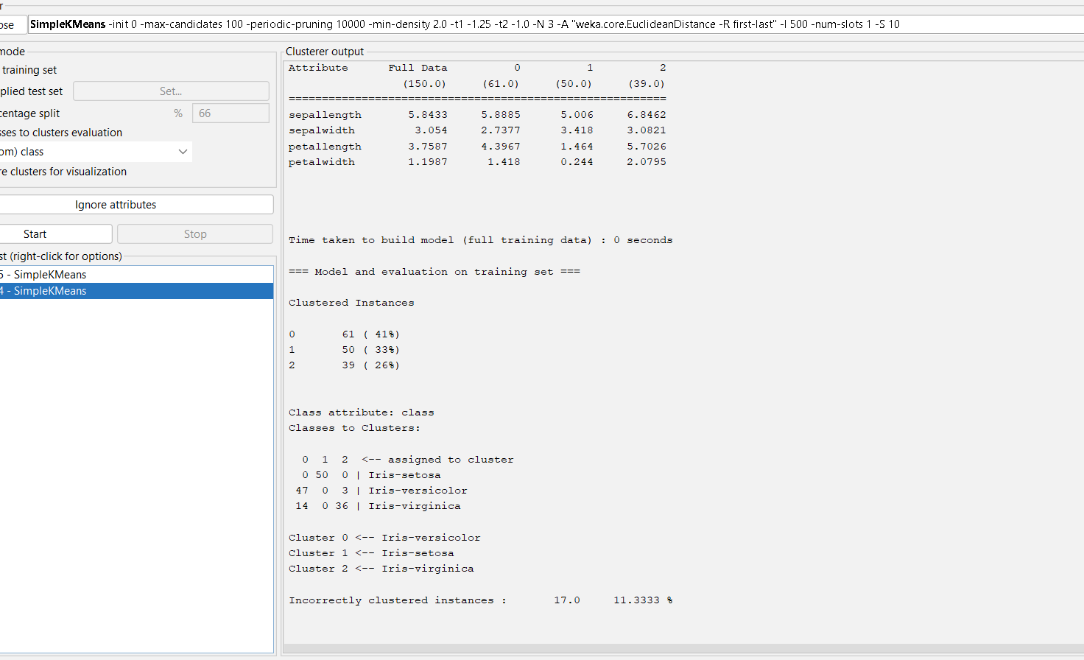

OUTPUT INFORMATION OF SIMPLE K MEANS CLUSTERING –CLUSTERER OUTPUT

